目录
Introducing ZowieX 1
ZowieX Overview 3
Installation 3
The Interface 4
Searching 8
Upgrading 9
Device grouping 11
Device Control 13
Preset position setting 16
Camera configuration copy 17

Introducing ZowieX
1、Supported Device
This release supports the following ZowieTek devices：
- 4K NDI Video Encoder/Decoder
- 4K POV Camera
- 4K Surgical Video Camera
- 4K NDI Medical Video Recoder Lite
- 4K PTZ Camera
- 4K HDMI Video Recorder
- SDI NDI Video Streaming Eecoder Decoder

2、Feactures
ZowieX can provide different features depending on different devices.
Device discovery
All ZowieTek devices can be discovered by ZowieX and have shortcut access to the Web console.
Firmware upgrade
All ZowieTek devices can be upgraded/batch upgraded using ZowieX.
Grouping function
All ZowieTek devices can be grouped using ZoweieX for more convenient and faster operation.
Tally light
The following devices support the use of ZowieX to modify the parameters of the tally light:
- 4K NDI Video Encoder/Decoder
- 4K POV Camera
- 4K Surgical Video Camera
- 4K PTZ Camera

Parameter copy
The following devices support the use of ZowieX to copy parameters:
- 4K POV Camera
- 4K Surgical Video Camera
- 4K PTZ Camera
3. Requirements
Recommended system requirements
Operating system:
Windows: Windows 10 and above
macOS: MacOS 11 and above
Hardware requirements:
CPU: Intel i5 9th Generation
RAM:16 GB
Free storage space: 1GB
Minimum system requirements
Operating system:
Windows: Windows 10
macOS: macOS 11
Hardware requirements:
Processor: Intel i3 5th Generation
RAM: 8GB
Free storage space: 500MB

ZowieX Overview
ZowieX allows users to discover, manage, and upgrade all ZowieTek devices on the same network.
All ZowieTek devices will be automatically discovered by ZowieX and the key information of ZowieTek devices, such as IP, Tally light, NDI activation, firmware version, etc., will be conveniently and clearly displayed.
At the same time, it provides users with a more convenient way to enter the control interface of ZowieTek devices without querying and inputting information such as IP or mDNS.
ZowieX supports one-click copy and paste of all image-related configurations, and supports batch upgrade functions without repetitive operations.
ZowieX supports grouping and management of devices, and monitoring of devices in four-grid or nine-grid mode. Supports image parameter settings directly through Zowiex. Realizes preset position settings

Installation
- Please log in to ZowieTek's official website to download the installation package of ZowieX.
https://zowietek.com/product/zowiex/
2. After downloading, please unzip the file.
3. Double-click the installation package to install.


The Interface
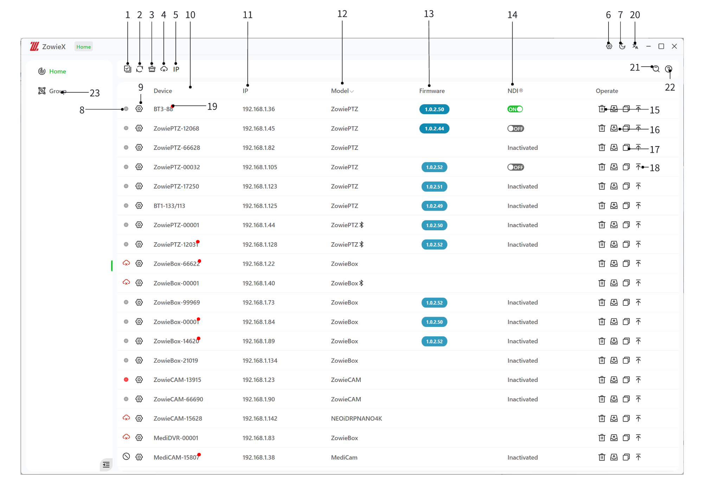
1: Multiple selection, select multiple devices of the same model for batch upgrade.
2: Refresh the interface and search for all devices on the current network
3: Clear the red dots on all newly discovered devices.
4: Delete all disconnected devices in the list.
5: Current scan mode.
IP: Scan according to the device's IP. When the IP changes, the device may be identified as a new device.
SN: Scan the device according to the device's serial number. The device will not be identified as a new device when the IP changes.
6：Enter the settings interface and set the ZowieX theme color and other information
7: Switch the interface to day/night mode.
8: Display the tally light color or device status:
Icon | Description
 | Device offline
 | Tally light is off
 | Tally light is green
 | Tally light is red
 | Tally light is white
 | No tally light

Click the tally light to directly change the tally light color and mode.
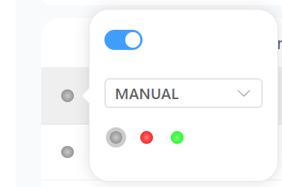
9: Shortcut button. Click to open the web console of this device.
10: Device name, double-click to modify the name of this device, the name cannot be empty
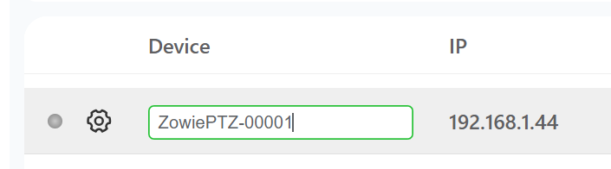
11: Device IP, click to obtain DHCP status, IP address, subnet mask, default gateway, MAC address, DNS and other parameters.
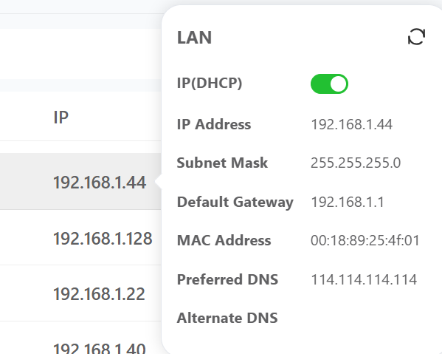
12: Device model
13: The firmware of the device, click to obtain the current software, hardware, ISP, web, NDI version information of the device, click the button in the lower right corner to directly copy all version information.
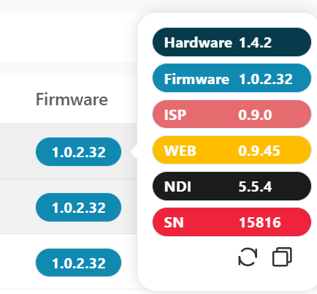
14: NDI status, click to obtain the NDI name, NDI status, NDI quality, NDI group, NDI discovery function and other information of the current device. If the information is not refreshed in time, please click the refresh button in the upper right corner.
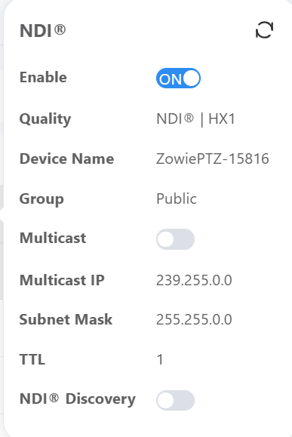
15: Delete button, delete the currently offline device from the list.
16: Upgrade button, click to upgrade a specific device.
17: One-click copy, Copy the image setting parameters of camera products to other camera devices.
18: Top, select the required device to top.
19: Indicates a newly discovered device
20: Switch ZowieX language
21: Search for device name/IP address/serial number
22: Quick guide
23: Group Interface
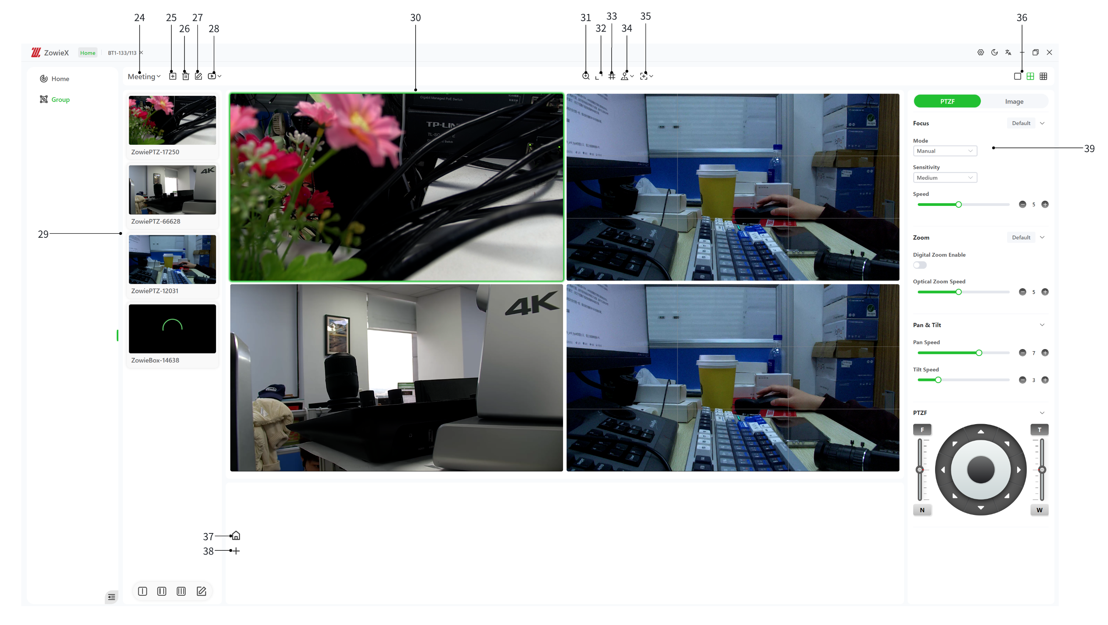
24: Current group name
25: Add group
26: Delete current group
27: Edit current group
28: Modify current group view mode
29: All devices in current group
30: Main window view
31: Use mouse wheel to adjust zoom
32: Zoom in current window
33: Add reference line
34: Use joystick to control P/T
35: Quick framing/centering
36: Switch main window to single window/four-grid/nine-grid
37: Switch to home preset position
38: Add preset position

Searching
1. After double-clicking to open the ZowieX software, ZowieX will automatically search for all ZowieTek series devices in the same LAN, and support searching for devices across network segments.
2. The next time searching, a red dot will appear in the upper right corner of the newly discovered device to indicate that the device is a newly discovered device.
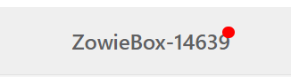
3. After the device is discovered, you can directly click on the device name to modify it. The name cannot be empty.
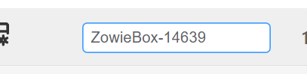
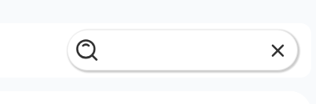
4. When there are too many devices, you can directly click the search button in the upper right corner and enter the device name or device IP to search.

Upgrading
Single device upgrade
- Please select the device to be upgraded and click the upgrade button on the right.
- Select the firmware to be uploaded and wait for the firmware to be decompressed successfully.
- After the decompression is successful, click the upgrade button in the lower right corner to upgrade.
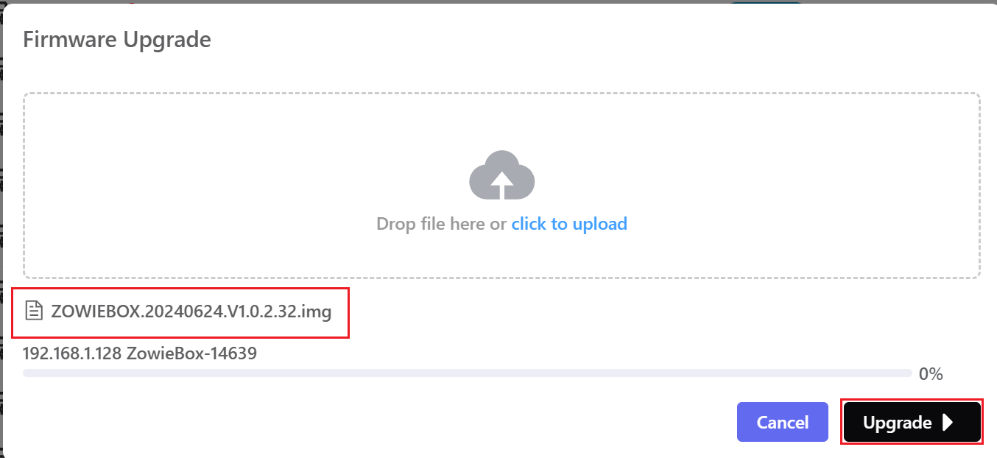
4. Please turn off the Wifi function of the device before upgrading, otherwise the upgrade will fail.
5.After the upgrade is completed, the device will automatically restart. Please wait patiently for the device to restart.
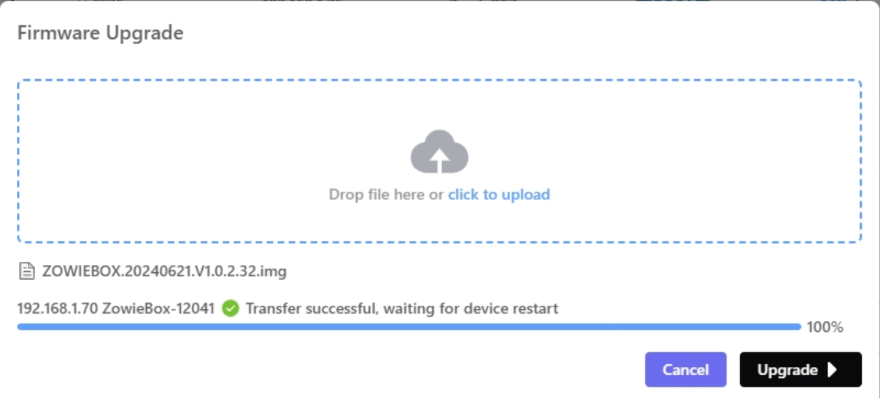

Batch upgrade
- Please click the multiple-select button in the upper left corner to select the device to be upgraded. (Due to different upgrade firmware, the device models of the devices to be upgraded in batches should be consistent)
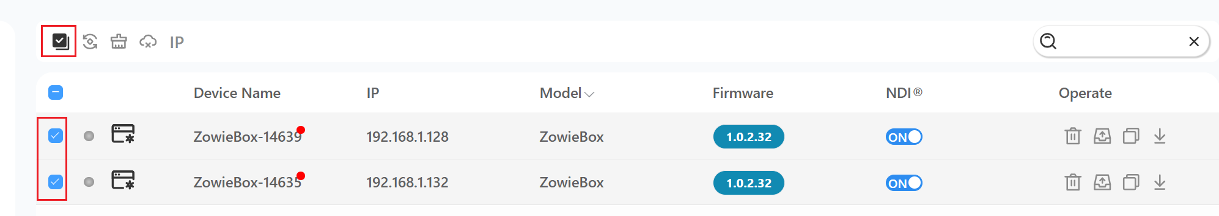
2. After the selection is completed, move the mouse to the multiple-select icon and select Upgrade.
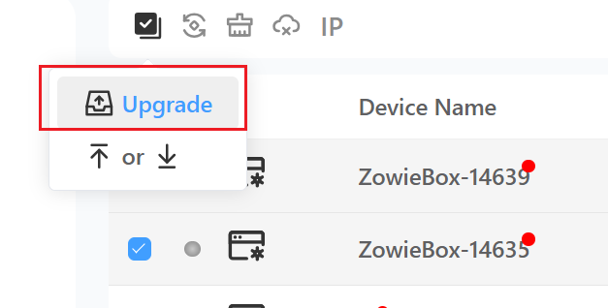
- Select the firmware to be upgraded and wait for decompression. After the decompression is completed, click the upgrade button in the lower right corner to upgrade.
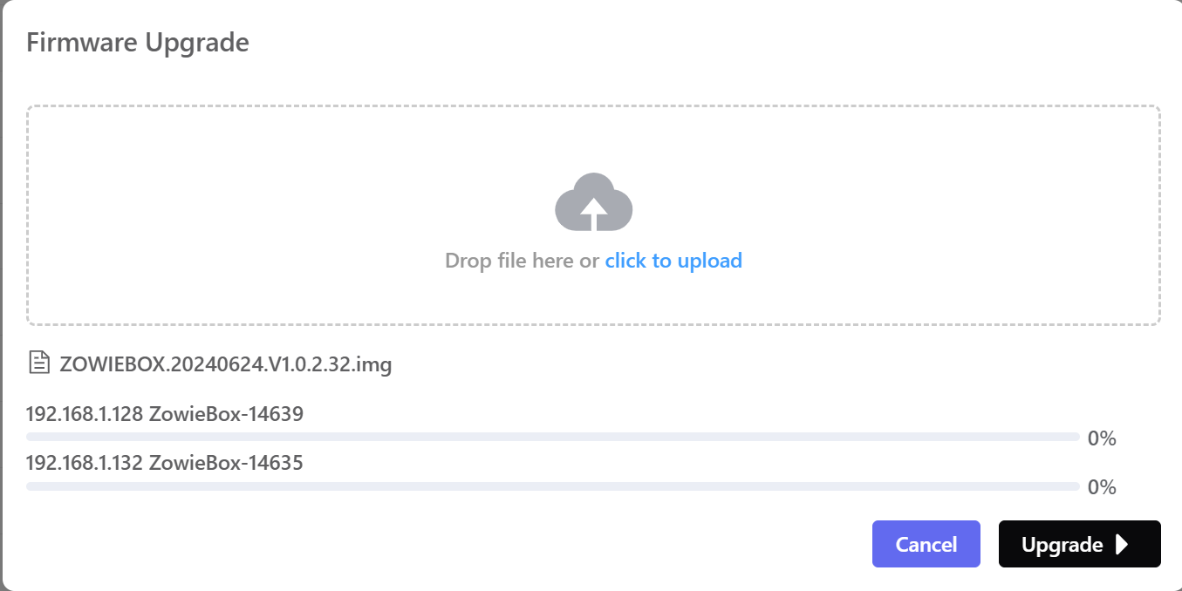
- After the upgrade is completed, the device will restart. Please wait patiently until the device restarts.

Device grouping
1. Click the left navigation bar to enter the device grouping control interface, and click the add button in the upper left corner to add devices
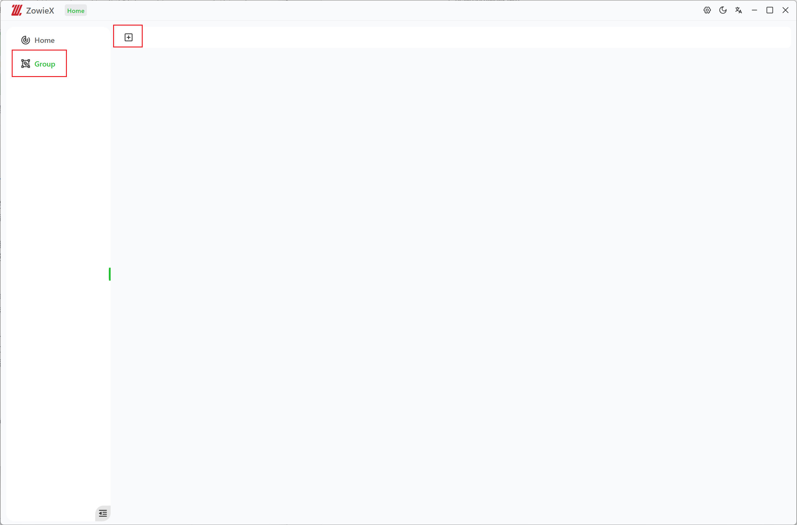
2. Enter the name of the group and the number of device source columns, and select the device to be added. Move the mouse over the device name to automatically display the current device screen, which is convenient for users to select devices.
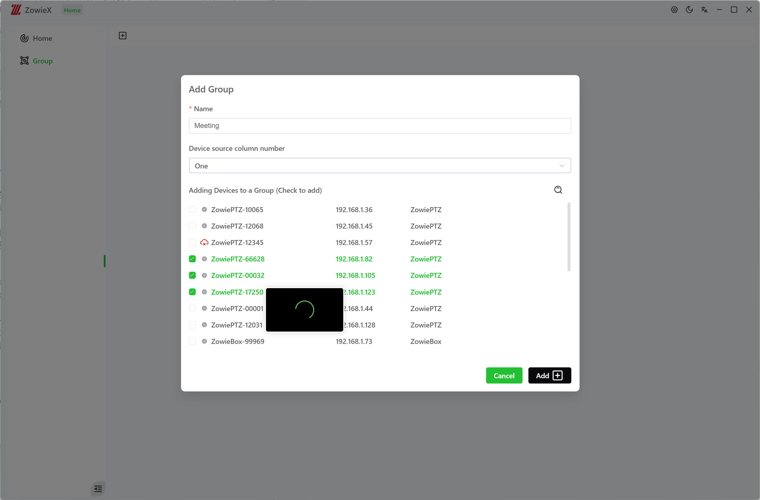
3. After adding, click the button above to switch the current view to table mode or video mode. In video mode, you can control and set parameters for the current device.
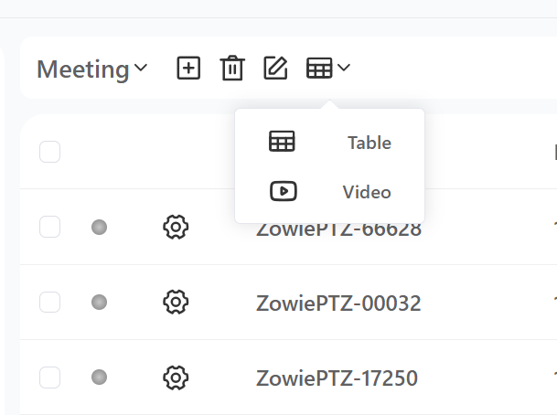
- The left column is all the devices in the current group. Click + or drag directly to add the device to the main view window.
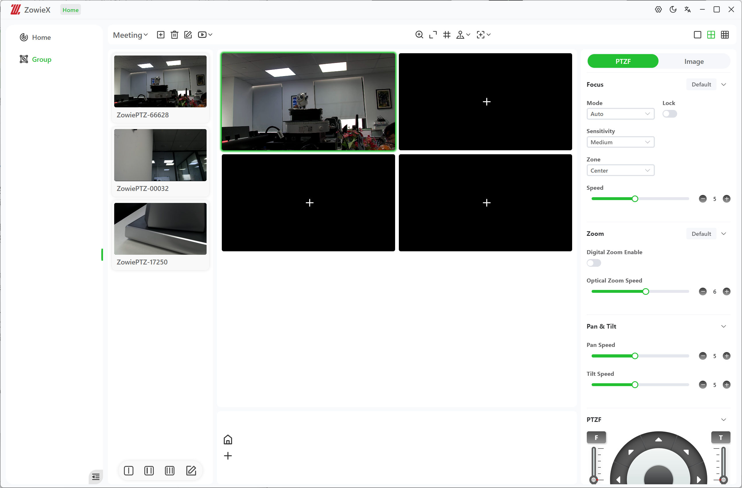
After adding, click the window of the device to be controlled, and the device’s image parameters will be displayed on the right.

Device Control
After entering the group page, click the window of the camera device you want to control. You can use the buttons above to perform basic control of the camera.
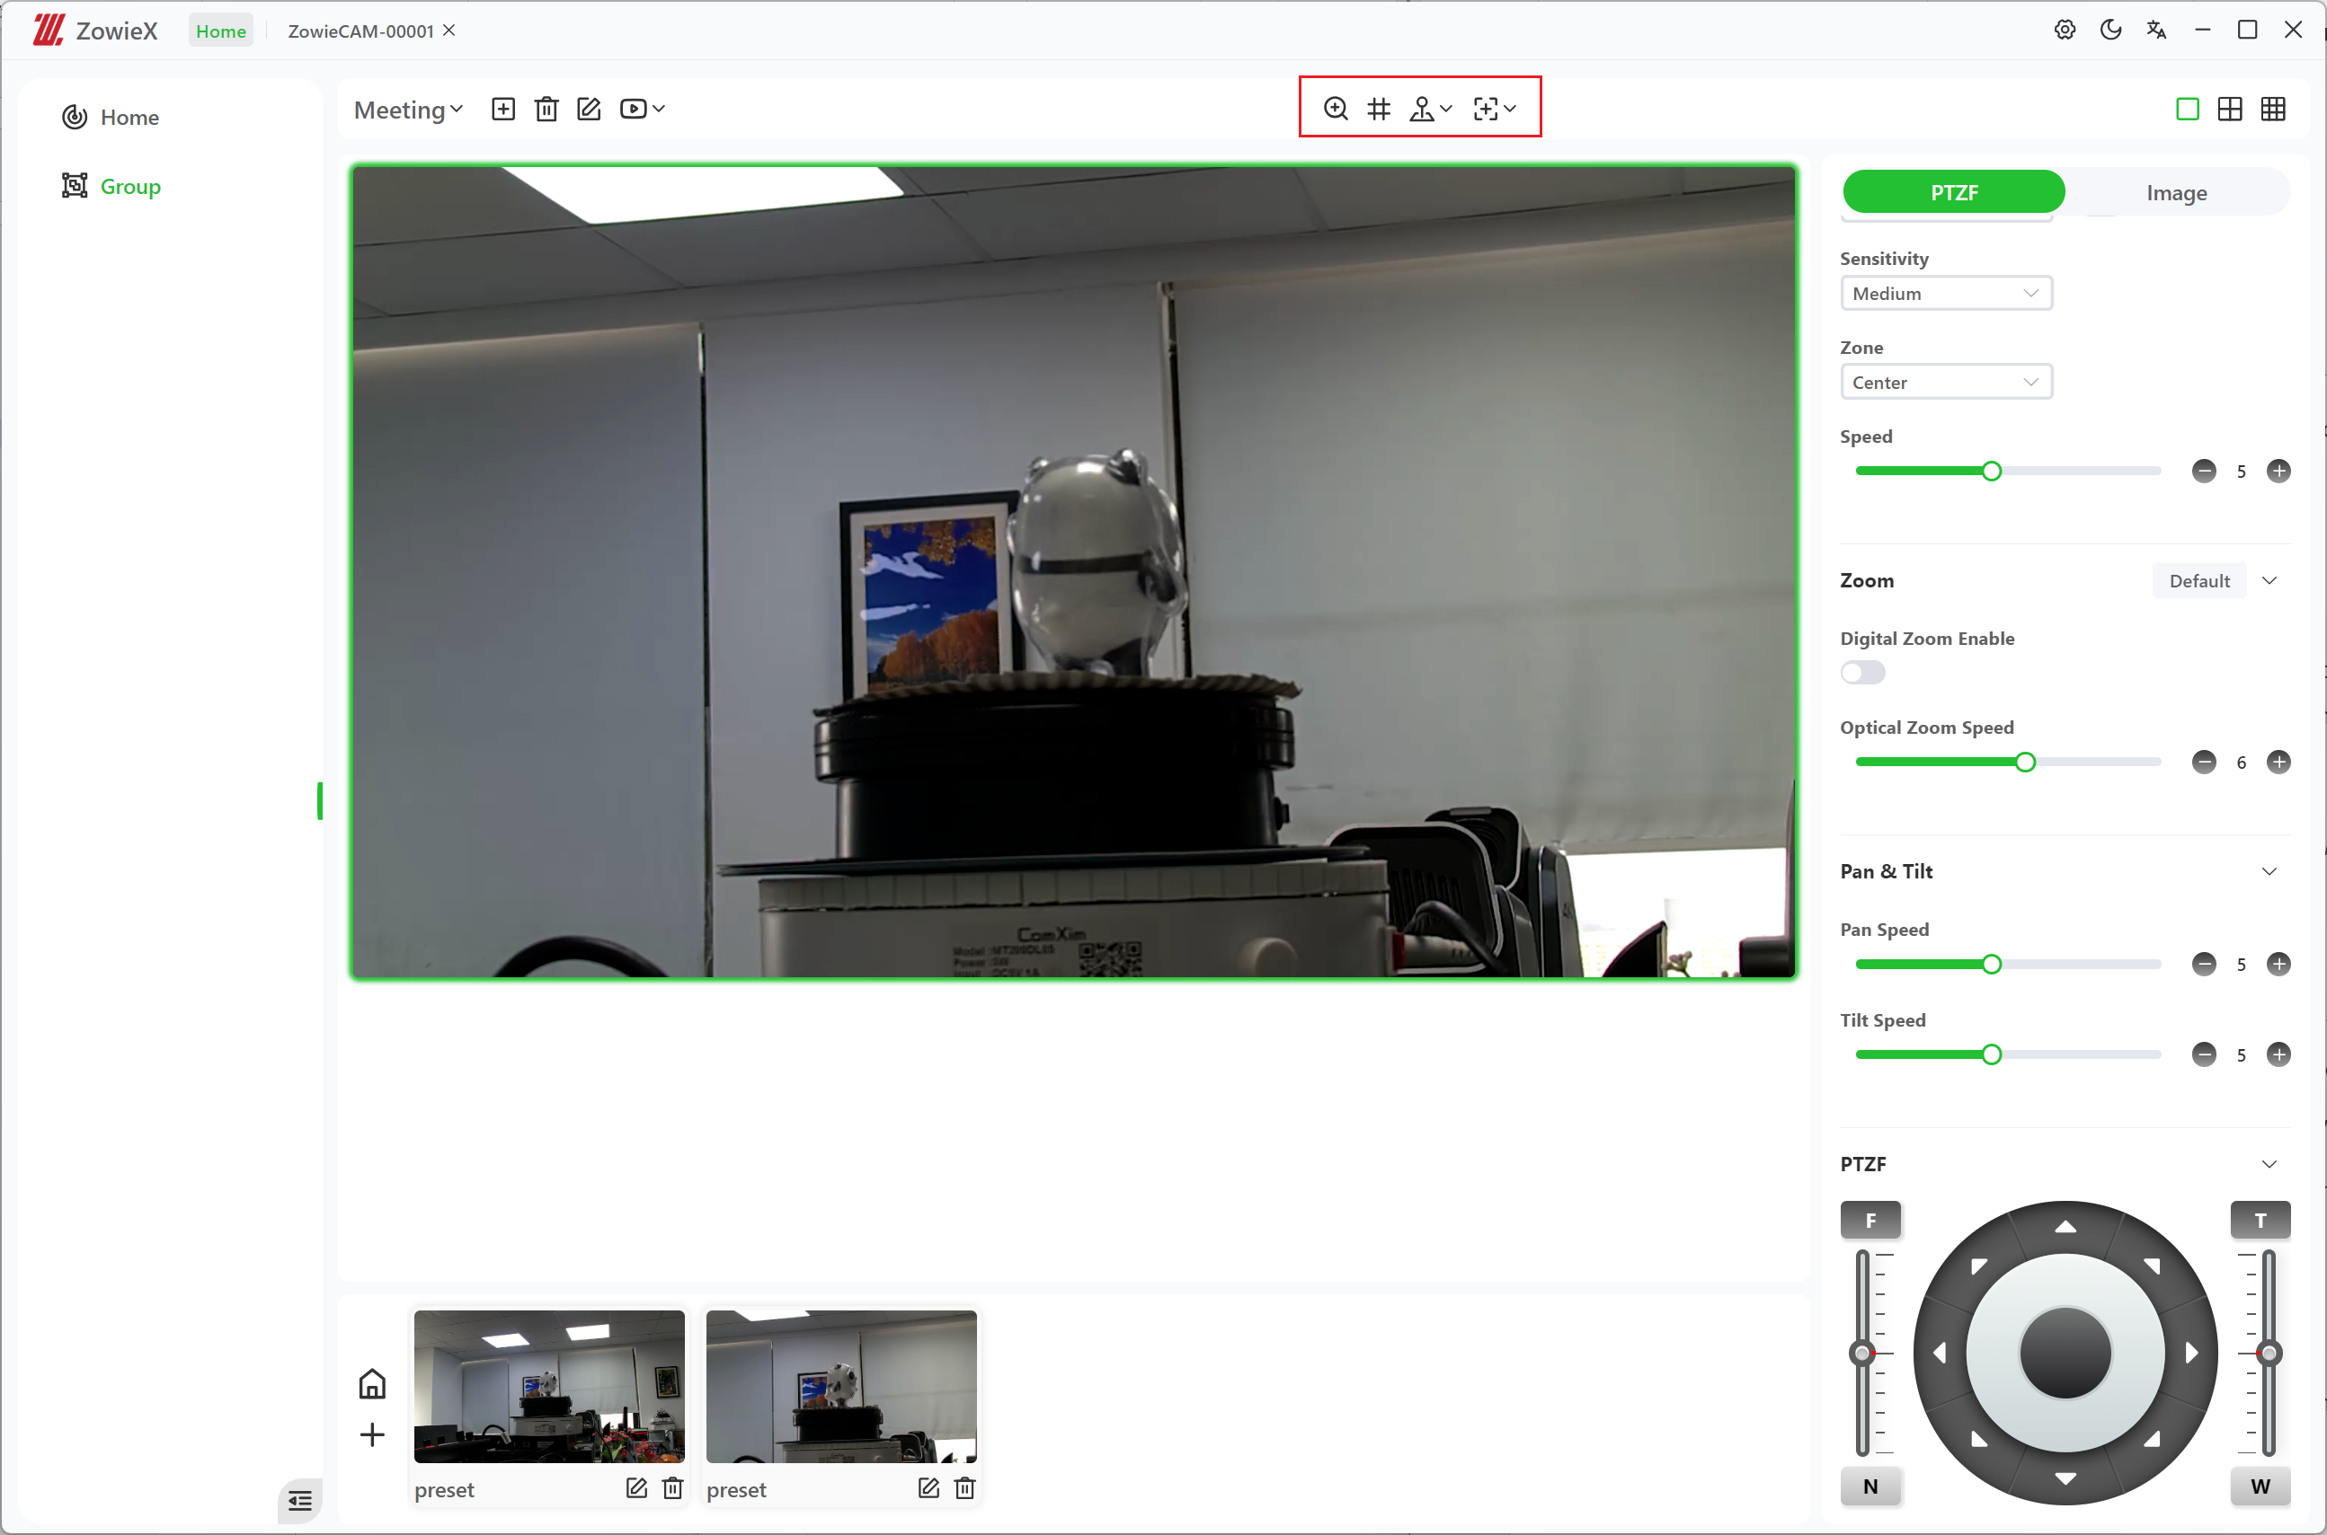
1. Click  to use the mouse wheel to zoom. Roll the wheel forward to zoom in, and roll the mouse backward to zoom out.

2. Click to use the mouse to operate the direction of the camera. Hold and drag the mouse in the window to steer the camera direction.The larger the mouse drag, the faster the camera moves.
If you only need to move horizontally/vertically, you can move the mouse to the icon and select the direction you want to move.
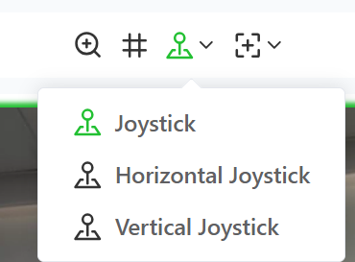
3. Click to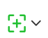 quickly center the required image. Move the selection box to the position you want to center and click, and the camera will automatically center the position.
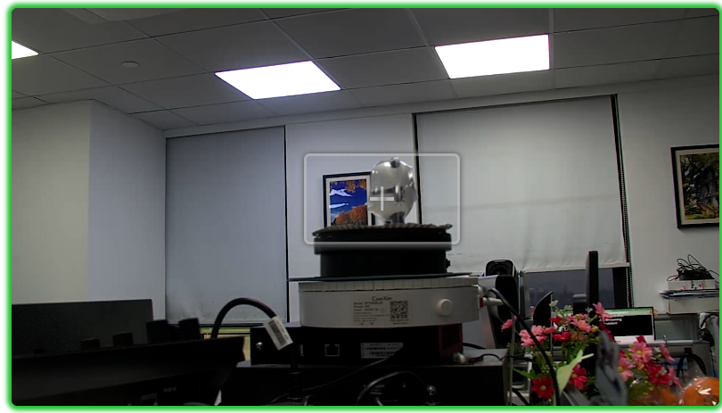
If you only need to center horizontally/vertically, you can move the mouse to the icon and select the direction you want to center.
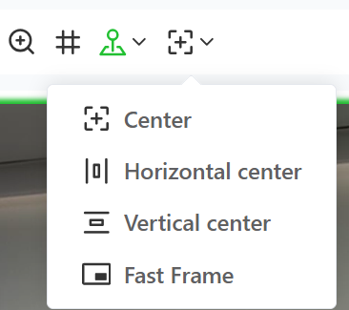
Select Fast Frame to zoom while centering the object. After selecting Fast Frame, roll the mouse wheel forward to center the object in the viewfinder and enlarge it by the corresponding multiple. After selecting Fast Frame, scroll the wheel backwards, and the device will center the object in the viewfinder and reduce it by the corresponding multiple.
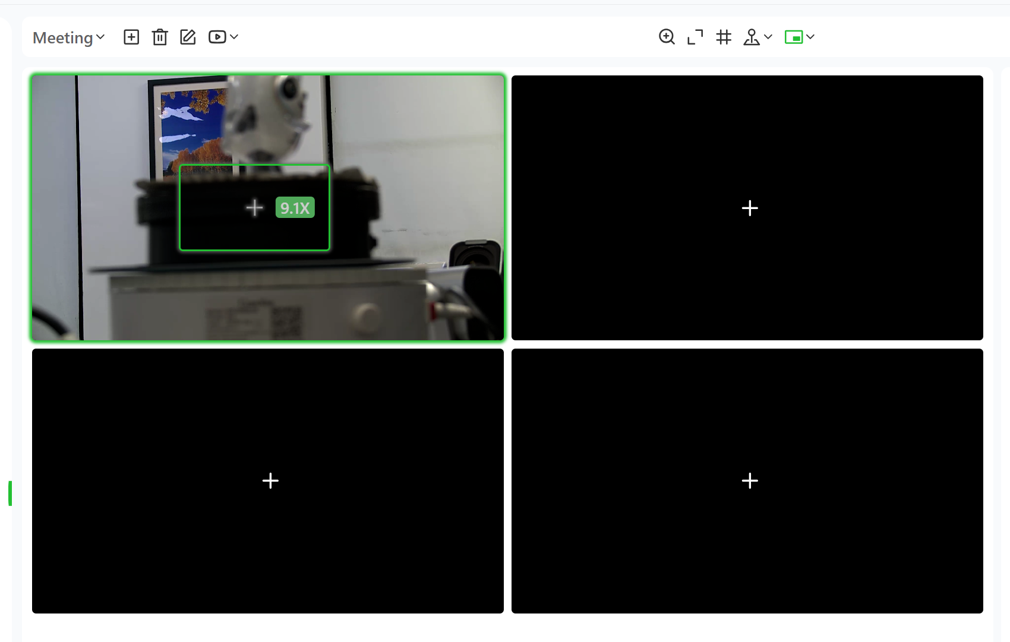
Notes:
1、When the camera moves to the boundary and cannot move further, the border of the window will automatically turn red to remind the user.
2、The above functions can be quickly operated using the keyboard. Click the settings button in the upper right corner to view all shortcut keys.
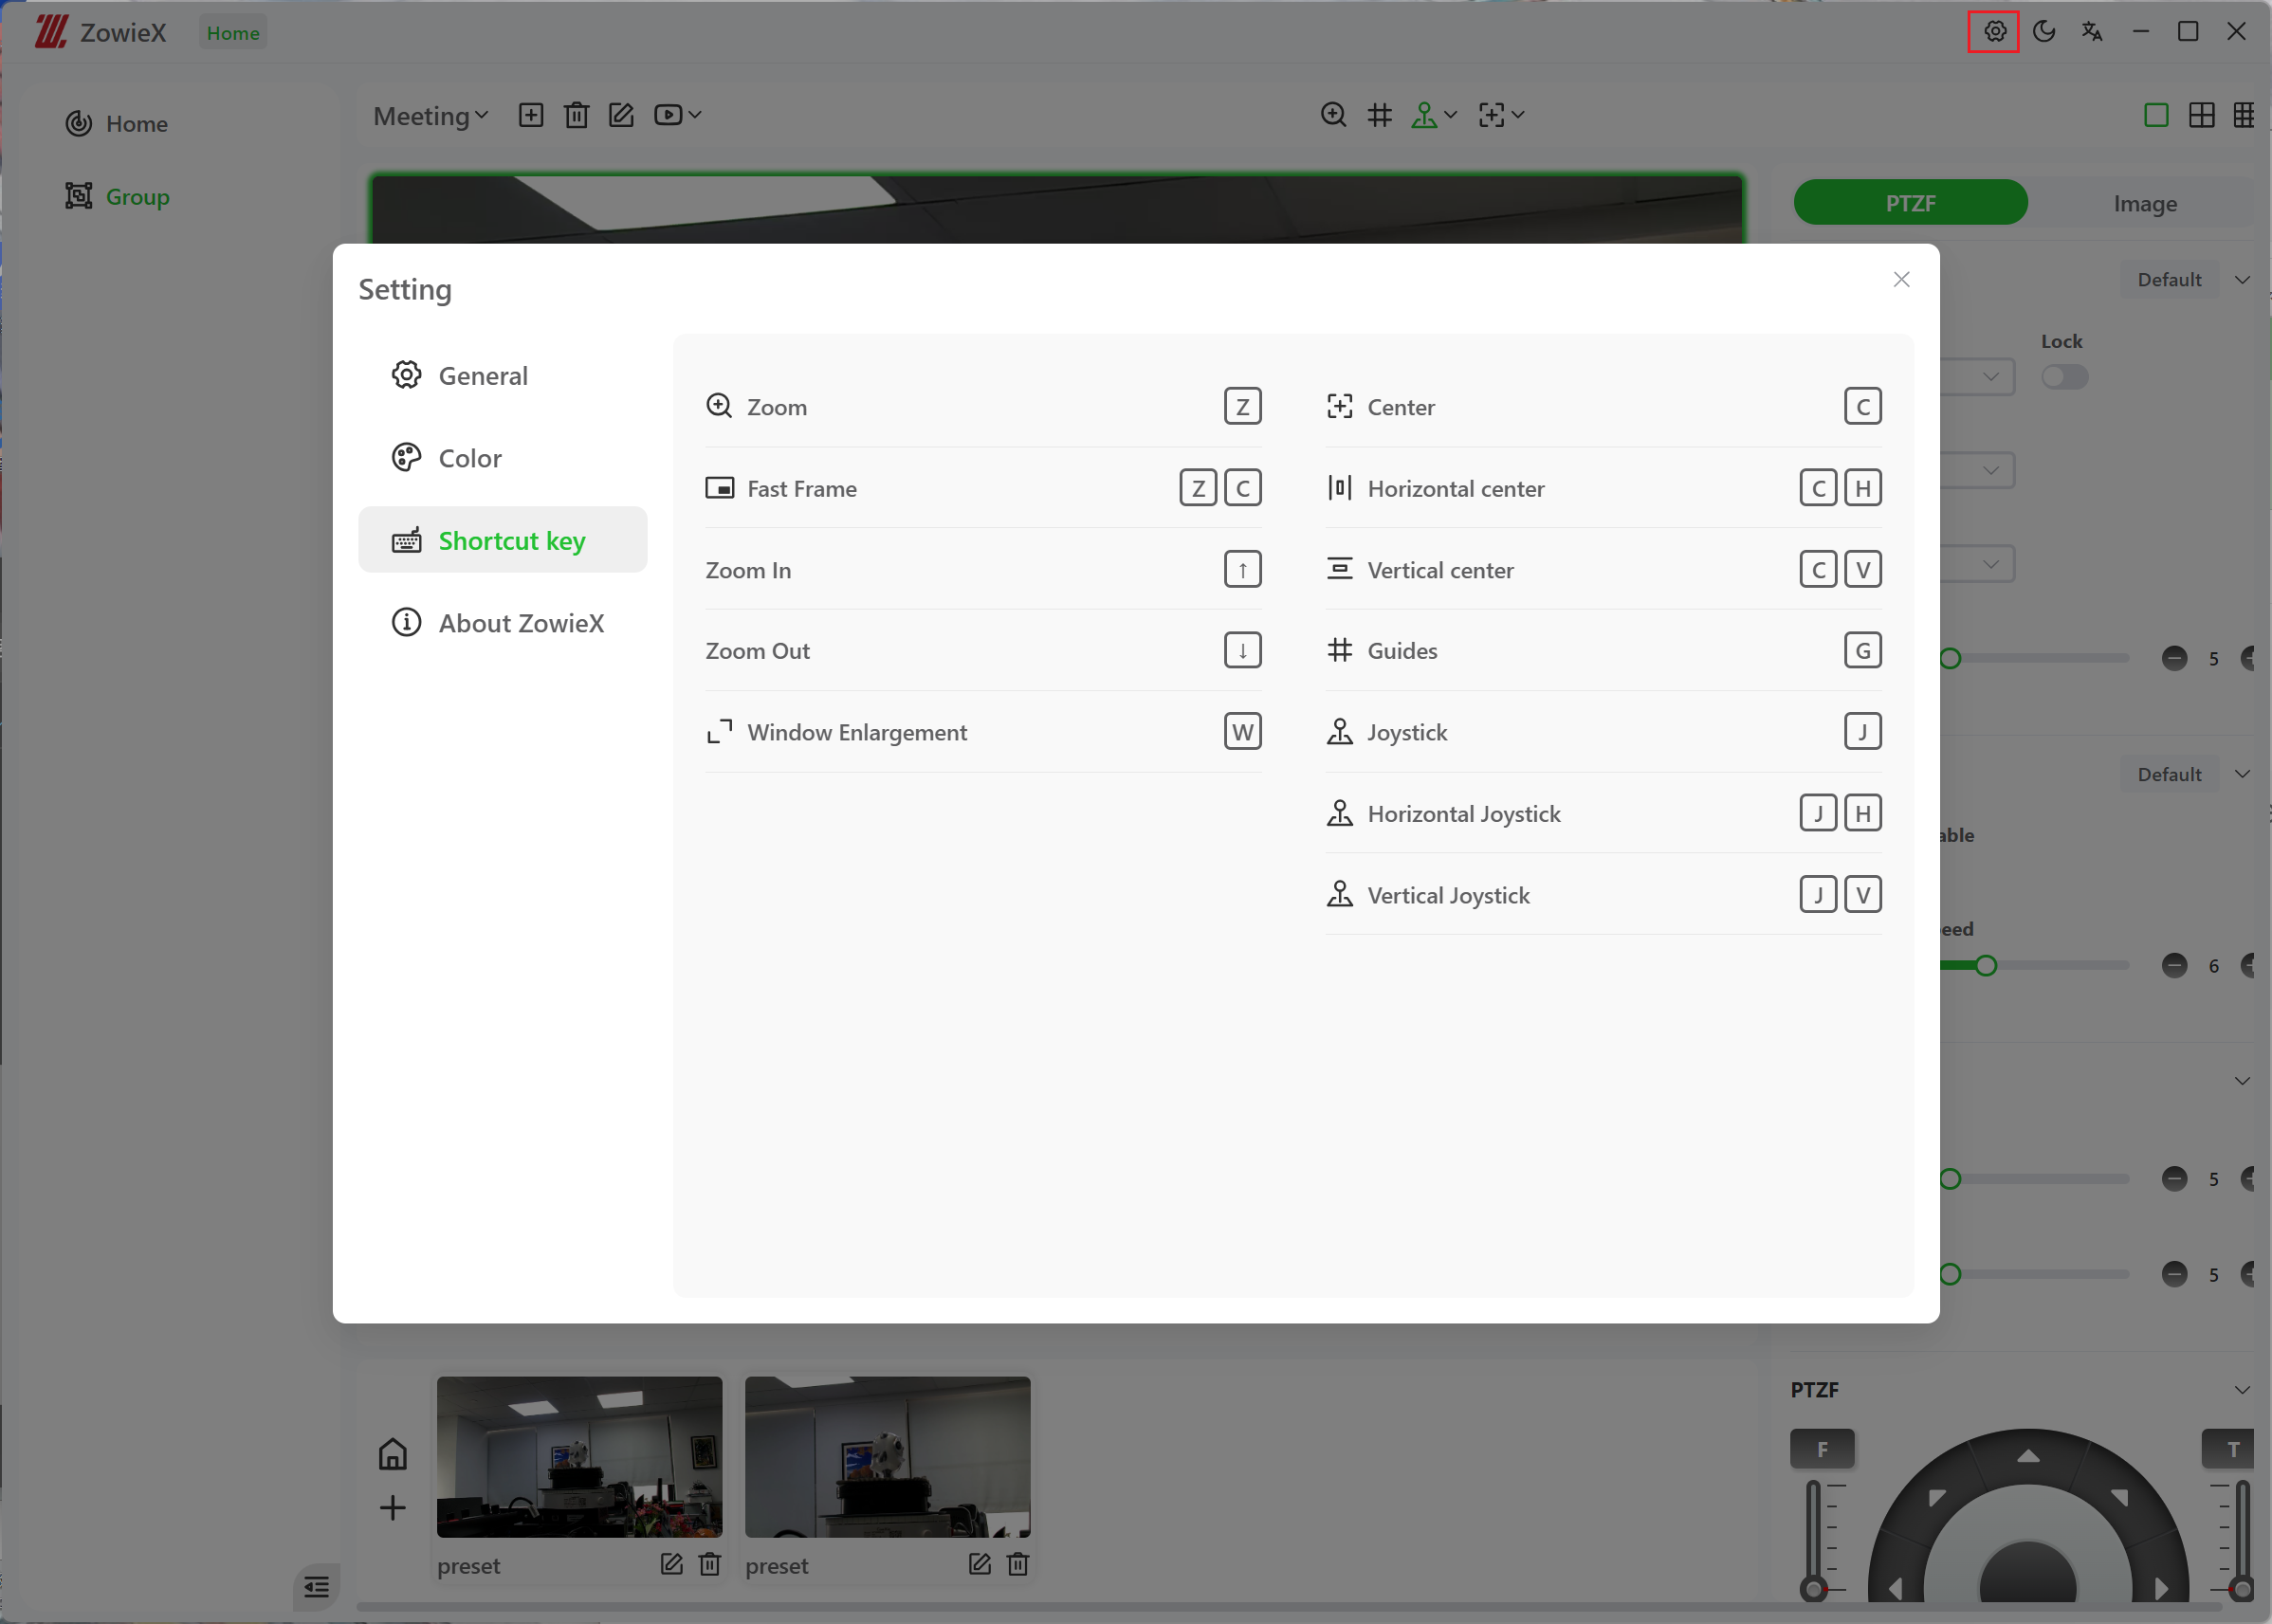

Preset position setting
After entering the group interface, click the window which you want to set the preset position.
Click  to return to home position.
Click the + below to save the current position of the camera device as a preset position.
Directly click the preset position image below to call the preset position.
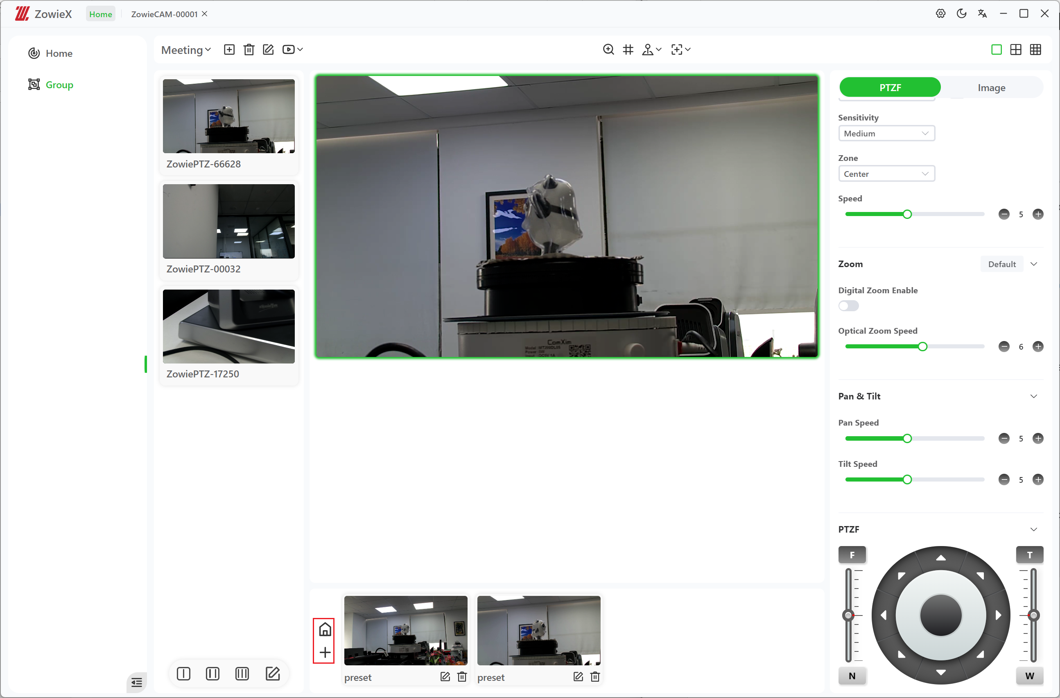

Camera configuration copy
1. Select the device to be copied and click the copy button on the right.
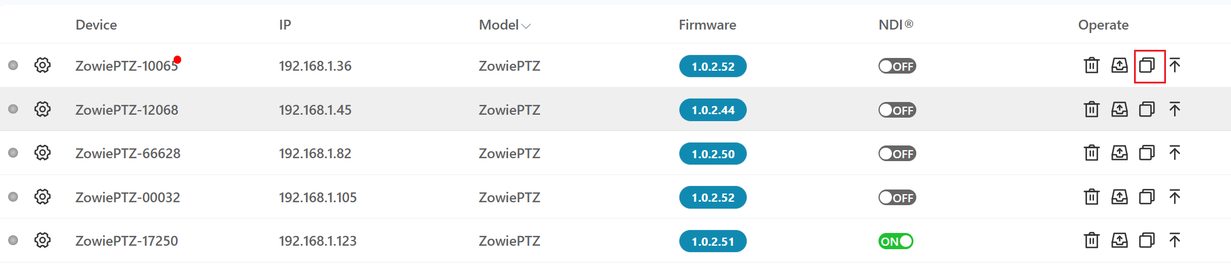
2. Select the camera configuration to be copied and the device to be pasted. After the selection is completed, click the copy button in the lower right corner to copy. Currently, only devices of the same model can be copied.
